News Release
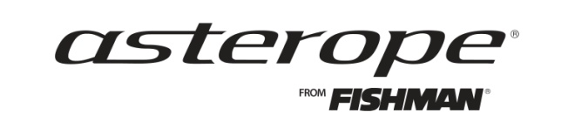
Media contact:
Dean Kline
512-751-2263 or dean@asterope.com

ASTEROPE ANNOUNCES STRATEGIC INITIATIVE TO ENTER
PRO AUDIO MARKET
Company Launches Next-Generation Marketing Campaign

AUSTIN, Texas – Jan. 23, 2014… Building on its successful launch into the music instrument market, Asterope has announced a strategic initiative to expand into the professional audio market, focusing on professional and home recording studios. Recording studios are among the most demanding settings for audio quality and Asterope’s breakthrough technology – with its greater clarity, broader frequency response and more dynamic harmonics – is ideal for this environment.

A number of world-class recording studios and engineers have already begun implementing Asterope technology in their studio infrastructures, using Asterope’s instrument cables, XLRs and speaker solutions to dramatically improve their signal paths. Bil Vorndick, renowned Nashville audio engineer who has produced or engineered eight GRAMMY award winning albums and more than 30 GRAMMY award finalists, has standardized on Asterope cable technology for his recording work.

“I use Asterope in the recording studio because of the definition it gives me on both the low end and high end, giving me definition in frequencies I haven’t heard before using other cables,” said Vorndick. “In addition to music instruments, I use Asterope as the signal path from my microphones to my mic pre-amp. Asterope has a much more open sound, giving me better definition, which is what I want to hear.”

“Studio professionals are very excited about Asterope’s unique technology and the benefits they are experiencing in their recording environments,” said Dariush Rad, president of Asterope. “Session players, recording engineers and producers are all very sensitive to the quality of their tone and understand the importance of the signal path. Asterope is ideally suited to meet their needs.”

- more -

ASTEROPE ANNOUNCES STRATEGIC INITIATIVE
2 -2 -2

New Artist Campaign Supports Pro Audio Initiative
To support its expansion into pro audio, as well as the company’s current MI initiatives, Asterope has launched its next-generation artist campaign. The new campaign features informative interviews of leading players, producers and engineers, giving the artists an opportunity to share the stories of their careers and their reasons for choosing Asterope.

The marketing campaign features video and portraits shot by world-class photographer Ed Rode, whose portfolio spans two decades capturing iconic artists and celebrities. The images in the new campaign feature a series of high-energy, upbeat portraits depicting the excitement and inspiration musicians feel when using Asterope. The new campaign launches with a series of advertisements at Winter NAMM, on the company’s website (www.Asterope.com), FaceBook page, and YouTube channel, AsteropeTV (youtube.com/asteropetv).

About Asterope:
Asterope, LLC is an innovative audio cable technology company specializing in products
designed for the music, pro audio and high-end audio markets. Headquartered in Austin, Texas,
the company offers unique products using breakthrough technology for musicians, engineers and
audio enthusiasts. Asterope music instrument cables are distributed worldwide by Fishman. For more information on purchasing Asterope, call 800.FISHMAN or visit www.fishman.com/asterope.
The company can be followed on Facebook, Twitter and at www.asterope.com.

Asterope… The Signal of a New Era

# # #

