News Release
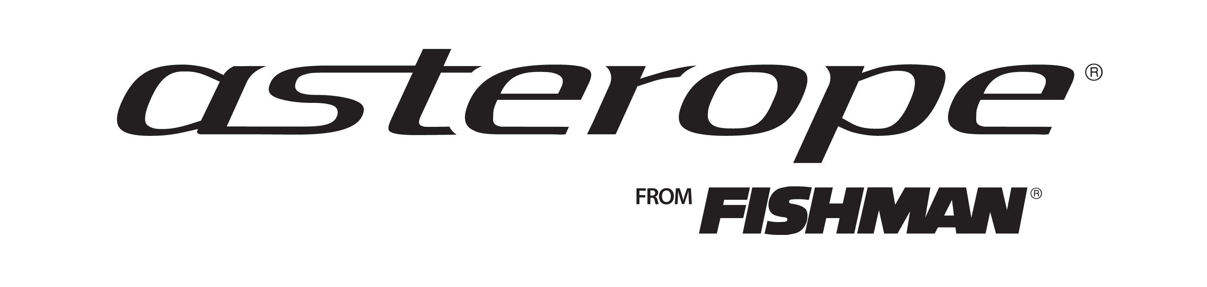

Fishman Media Contact:
Media contacts:
Dean Kline
512-751-2263 or dean@asterope.com
Chris DeMaria
978-253-5423 or cdemaria@fishman.com

FISHMAN BEGINS WORLDWIDE DISTRIBUTION OF ASTEROPE CABLES

Anaheim, CA––Fishman and Asterope announced at Winter NAMM 2013 that Fishman has begun worldwide distribution of Asterope cables to retail outlets throughout the United States and 70 countries worldwide. As part of the companies’ strategic alliance announced in July 2012, Fishman will manage the sales and distribution of Asterope instrument and XLR audio cables for the music instrument and pro audio markets globally. The two companies collaborate on marketing and promotional efforts for the Asterope brand in the music instrument and pro audio markets.

Offered in two product lines, the “Pro Studio” and “Pro Stage” series, Asterope premium audio products provide greater clarity, bandwidth, spectral balance and harmonic response for musicians, audio engineers and enthusiasts alike. Asterope products, designed and manufactured in the United States, are the result of more than a decade of research and development. Since their introduction, the company’s breakthrough products have become the cable of choice for industry professionals for both live performances and session work.
“This is an exciting opportunity for Fishman to expand on its commitment to provide the best possible sound,” said Larry Fishman, President of Fishman. “Every so often something revolutionary comes along that re-defines a category in our industry. This is one of those times. We’re delighted to be able to offer our experience and expertise, and look forward to making Asterope a success around the world.”
“With Asterope cables now being distributed by Fishman globally, artists around the world will be able to take advantage of the dramatic improvements in sound provided by this revolutionary technology,” said Dariush Rad, president of Asterope. “We are very proud to be aligned with Fishman. Working with such a well-respected, progressive and highly prolific organization, while partnering with an industry icon like Larry Fishman. is monumental for the company.”
For more information about Fishman and Asterope, stop by Booth #4258 in Hall C at the Anaheim Convention Center, or go to www.fishman.com/asterope .

About Asterope:

Asterope, LLC is an innovative audio cable technology company specializing in products
designed for the music, pro audio and high-end audio markets. Headquartered in Austin, Texas,
the company offers unique products using breakthrough technology for artists, producers and engineers. The company can be followed on Facebook, Twitter and at www.asterope.com.

About Fishman:
Since 1981, the Fishman name has been synonymous with acoustic amplification. With over 30 patents, engineer/musician Larry Fishman continues to drive the acoustic amplification market with innovative products and technologies that redefine the benchmark of acoustic sound. The company’s diverse, category leading product line includes the industry standard Matrix Infinity, SA220 performance system and Loudbox amplifiers. Fishman is located in Andover, MA and may be found online at www.fishman.com.

# # #

